**Introduction to computer vision**

What is computer vision?

Computer vision is a field of computer science which is responsible for developing computer programs that can interpret the image( or video ) to understand the image( or video ) in the same way as human vision does.

Applications:

1. Face recognition: It can be used for different purpose like face unlock feature in mobile phones, or in automatic attendance marker or detecting faces of suspect from in any criminal case.

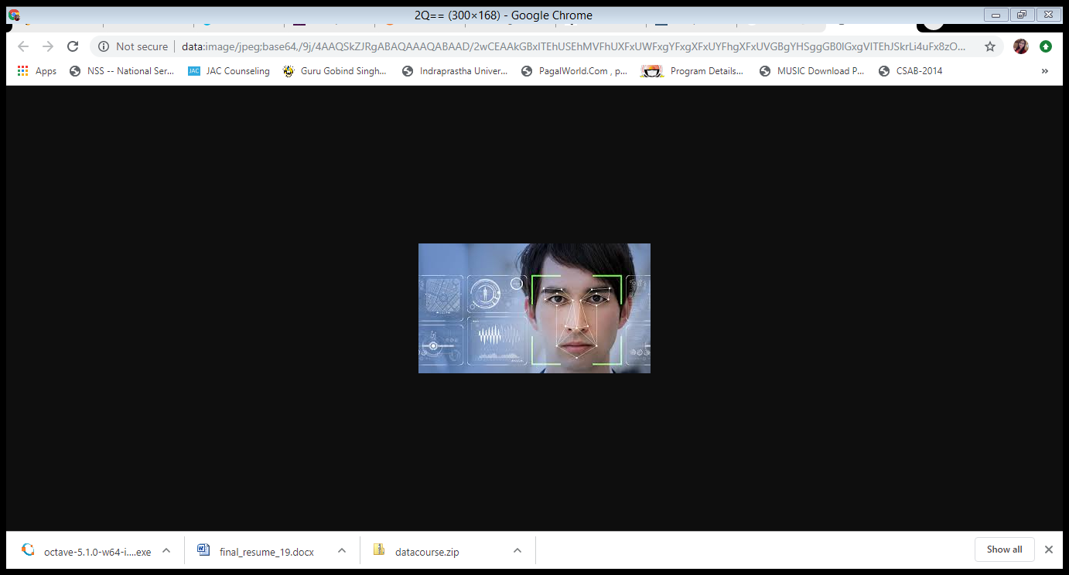

1. OCR( Optical Character Recognition ): It can be defined as machine recognition of printed text characters which can be used to recognize text inside images, such as scanned documents and photos.

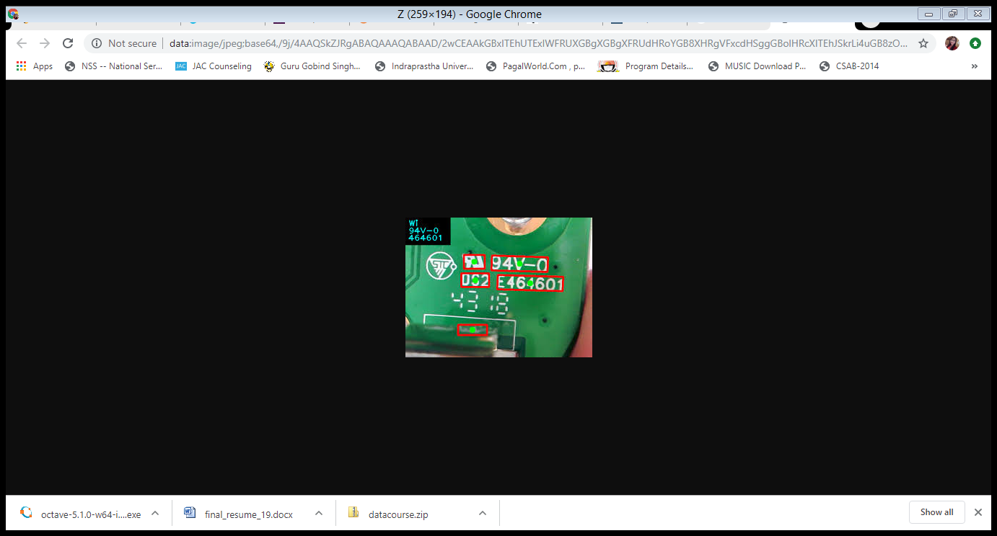

1. Medical Imaging: Used in image guided surgery, CAT / MRI reconstruction and assisted diagnosis.

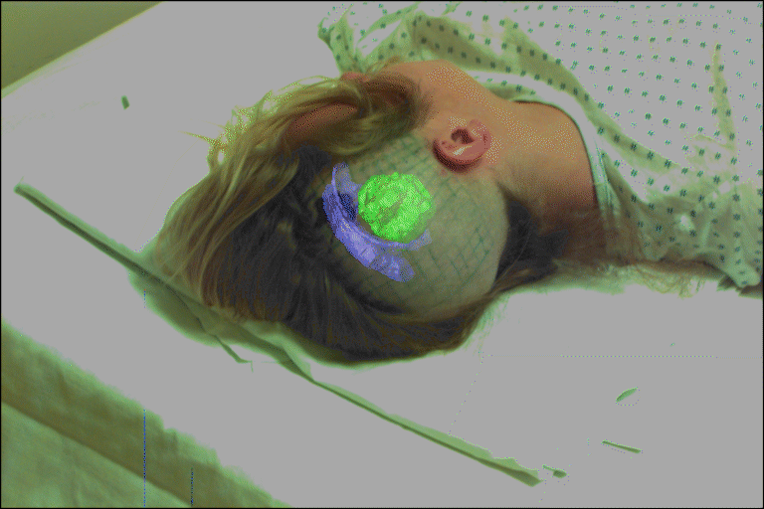

1. 3D modelling: Can be used to view the 3D view to any object, earth viewer and scene reconstruction.

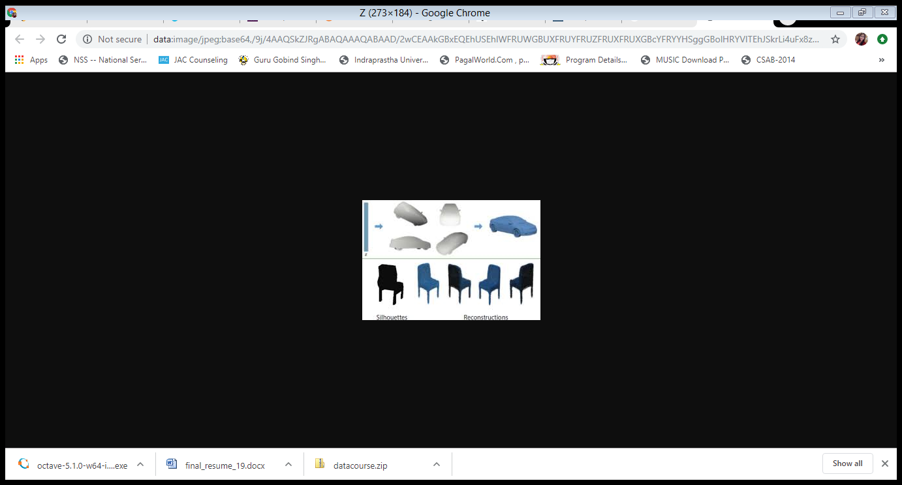

1. Smart Robots: Used in auto-driven cars and advance robots.

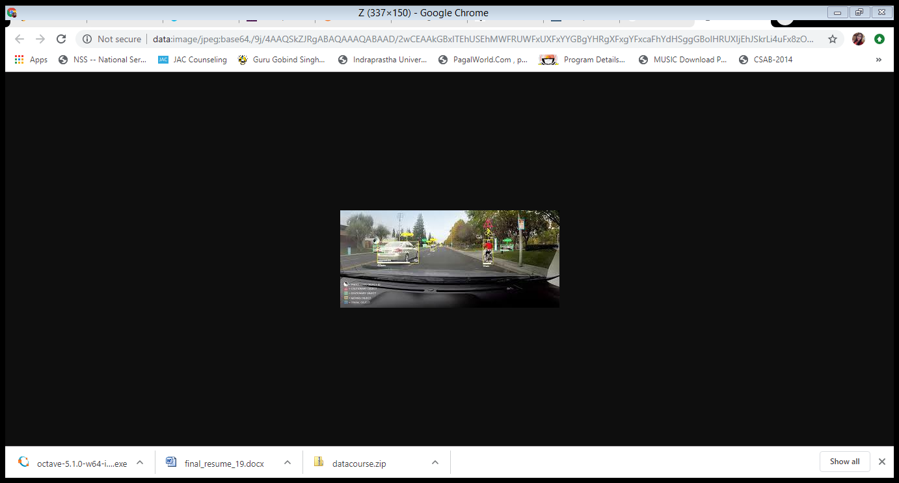

1. Vision based interaction: Used in a wide range of computing scenarios in addition to standard desktop computing, especially mobile, immersive and ubiquitous computing environments. For example- Nintendo Wii and Microsoft Kinect.
2. Special Effects: Shape capture, depth capture and motion capture etc.

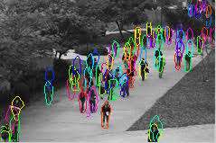

Why Computer vision is challenging?

It is not easy to interpret an image like humans do as the human brain is quite complex, it considers it’s past experience also to get into any final decision.

For example: Compare the color of block A and B. Which one is brighter according to you?

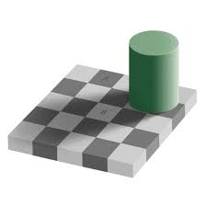

Do you think B is brighter than A?

Actually both the blocks are of same brightness, it’s just the illusion of our eyes because from our experience we know B is white in color and just the shadow of cylindrical block is making it dark but block A is originally black in color, hence we conclude that B is brighter than A.

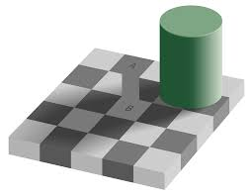

Future of computer vision:

The market for computer vision is growing very fast. It is estimated that it will reach [$26.2 billion](https://www.embedded-vision.com/industry-analysis/market-analysis/computer-vision-hardware-software-and-services-market-reach-262-bi) by 2025 i.e., growing more than 30 percent per year.

As the commencement of new technologies, the scope of computer vision is also increasing. For example:

* It can be combined with NLP( natural language processing ) to interpret different languages.
* It can be used in artificial general intelligence (AGI) and artificial superintelligence (ASI) to give robots the ability of processing information even better than the human visual system.

Computer vision currently is an emerging technology, hence it has so many great opportunities and also there are many fields related to it which are yet to be explored.